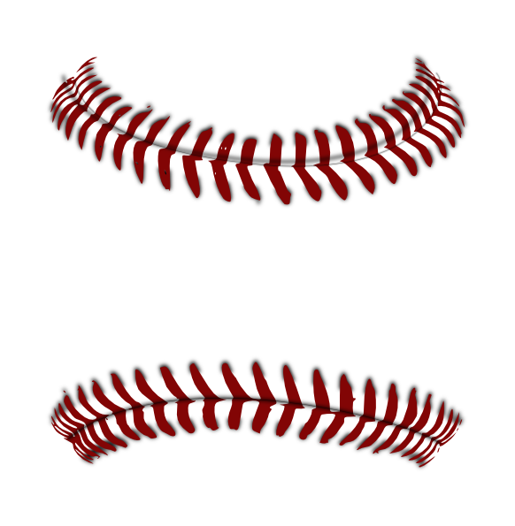

TJYGS

TJ Youth Girls Softball
2022 Sponsorship Form

Sponsor Name: ________________________________________________________________________

Mailing Address: _____________________________________________________________________

Phone No: ___________________________________________________________________________

Web Address: ________________________________________________________________________

Contact Name: _______________________________________________________________________

Contact No: _________________________________________________________________________

Email: ______________________________________________________________________________

Our sponsors will get their logos put onto our website, and will also be displayed on a large banner at our snack shack. Each team will have a sponsor allocated to them and we will put the sponsor name on the back of the girl’s jerseys for our slow pitch and instructional leagues. The fast pitch team sponsors will get a team banner they can display at the games.

How would you like your sponsorship to be displayed on the Team Jersey and or Team Banner?

__________________________________________________________________________

Sponsorships:
Team Sponsorships: minimum $150.00 Donation
- Sponsor Name on Team Jersey or a team banner (fast pitch teams)
- Listing on 3’ x 14’ Banner located at Mowry 1 Snack Shack
- Team Picture/Plaque for you
- Listing on TJYGS Website: www.tjygs.org

Please send this form, checks (payable to TJYGS), and your logo to

TJYGS
628 Inglefield Drive
Pittsburgh, PA 15236

Tax Identification Number for TJYGS: 45-5044666

